Clinical Question Answering With Medical LLMS (DocBot AI)
Project Proposal
Submitted in partial fulfilment of the requirement for the Final Year Project
Of
Bachelor of Science Artificial Intelligence

Submitted By | Humna Imran (2023-BS-AI-017)
Submitted By | Ayesha Imran (2023-BS-AI-057)
Submitted By | Maham Nisar (2023-BS-AI-058)
Program | BS Artificial Intelligence
Supervisor | Muhammad Arham
Co-Supervisor | Muhammad Arqam
Submission Date | 19 Sept. 26



Department of Computer Science
The University of Faisalabad

Abstract
DocBot AI is a clinical question-answering system that uses large language models (LLMs) to help healthcare providers and patients get accurate, evidence-grounded answers to medical queries. General-purpose LLMs can produce confident-sounding but factually incorrect responses, a problem known as hallucination, and this is unacceptable in a healthcare setting. DocBot AI deals with this by combining retrieval-augmented generation (RAG) with a curated medical knowledge base built from clinical guidelines, verified medical literature, and treatment references. Instead of relying only on the model's internal knowledge, which can be outdated, the system retrieves the most relevant verified passages for each query and grounds its answer in those sources. Citations are shown alongside every response so the user can check where the information came from. DocBot AI is meant to support faster clinical decision-making, especially in resource-constrained settings where quick access to a specialist is not always possible. The system will be built as a chatbot with a FastAPI backend, a vector database for semantic retrieval, and a web or mobile front end. The main goal is to build a reliable, transparent, evidence-grounded clinical assistant that lowers the risk of hallucination and helps both healthcare providers and patients make better-informed decisions.

Table of Contents
Abstract 2
1. Introduction 5
2. Problem Statement 5
3. Problem Solution for Proposed System 6
4. Literature Review 6
5. Advantages/Benefits of Proposed System 9
6. Software Process Methodology 10
7. Tools and Technologies 11
8. Project Stakeholders and Roles 12
9. Team Members Individual Tasks/Work Division 13
10. Project Domain 13
11. Gantt Chart 14
12. Conclusion 15
References 15

List of Figures
Figure 6.1 Object-Oriented Development Methodology for DocBot AI 5
Figure 11.1 Gantt Chart 9
List of Tables
Table 4.1 Comparative Analysis of Recent Clinical LLM/RAG Studies and DocBot AI 3
Table 7.1 Tools and Technologies for Proposed Project 5
Table 8.1 Project Stakeholders for Proposed Project 6
Table 9.1 Team Member Work Division for Proposed Project 7

1. Introduction
Large language models (LLMs) are increasingly used to answer everyday questions, and both patients and healthcare providers are turning to them for medical information. However, general-purpose LLMs are trained to sound fluent and confident, not to be clinically accurate. They frequently “hallucinate,” meaning they produce plausible-sounding but factually incorrect statements. In a medical context, an incorrect answer about a symptom, medication, or dosage can have serious consequences. At the same time, access to a specialist for a quick clarifying question is not always immediate, particularly in resource-constrained settings where the doctor-to-patient ratio is low. DocBot AI is proposed to address this gap through an AI-based clinical question-answering system. Rather than depending purely on an LLM's internal knowledge, DocBot AI combines the model with retrieval-augmented generation (RAG). Every query is first matched against a curated, verified medical knowledge base, and only the retrieved, evidence-backed passages are used to generate the final answer, along with citations back to the source. This grounds the system's responses in verifiable clinical sources and reduces the risk of hallucination. DocBot AI aims to provide a fast, trustworthy, and accessible information layer that supports healthcare providers making time-pressured decisions and patients trying to understand their own health better.

2. Problem Statement
Most general-purpose LLMs are built for broad conversational fluency rather than clinical accuracy, and they are not required to cite the source of a claim. When used informally for medical questions, they can give answers that sound authoritative but are factually wrong, outdated, or not applicable to the specific clinical context. Existing medical information tools are also often split across separate systems: a search engine to find literature, a separate reference app for drug information, and a separate channel to actually reach a clinician. None of these are combined into one conversational system that understands a natural-language medical question and answers it using verified evidence. This problem is worse in resource-constrained settings, where the ratio of specialists to patients is low and people may not have quick access to an expert who can verify information. What is needed is a system that can understand natural-language clinical questions, retrieve the most relevant verified evidence, and generate an answer that is accurate and traceable to its source, not one that just sounds confident. DocBot AI is being developed to bring natural-language understanding, evidence retrieval, and citation-grounded answer generation together in one system. This should reduce the hallucination risk of general-purpose LLMs while staying fast enough for real clinical use.

3. Problem Solution for Proposed System
DocBot AI will provide an AI-based solution for evidence-grounded clinical question answering using retrieval-augmented generation (RAG). When a user submits a question through the chatbot interface, the query is first converted into a vector embedding. This embedding is used to run a semantic search over a vector database that holds the curated medical knowledge base (clinical guidelines, verified medical literature, and treatment or drug references), and the passages most relevant to the question are retrieved. The retrieved passages, together with the original query, are passed to the LLM through a structured prompt, and the model generates an answer grounded in that retrieved evidence rather than in its own unverified internal knowledge. Each answer is returned with citations to the specific source passages it was grounded in, so the user can check the underlying evidence. A relevance/confidence threshold is applied at the retrieval step. If no sufficiently relevant evidence is found in the knowledge base, the system will flag the answer as low-confidence and recommend consulting a qualified healthcare professional instead of guessing. The system will also support two response modes: a more technical mode for healthcare providers, and a plain-language mode for patients, so the same underlying evidence can be explained at the right level of detail for each audience. Query and answer logs, with sensitive information handled according to data-protection requirements, will be used to keep identifying gaps in the knowledge base and improving retrieval quality over time. The complete system will be tested for answer accuracy, groundedness (whether the citations actually support the answer), response latency, and usability.

4. Literature Review
Recent research on medical language models and retrieval-augmented generation (RAG) converges on one central idea: a language model becomes far more trustworthy in a clinical setting once its answers are tied to real, checkable sources instead of whatever the model happens to remember from training. Lewis et al. (2020) introduced RAG itself, pairing a neural retriever with a sequence-to-sequence generator so that every answer is grounded in retrieved passages rather than produced from parameters alone. Gao et al. (2024) later surveyed how this basic architecture has grown into naive, advanced, and modular RAG variants, mapping out the design choices (retrieval strategy, reranking, prompt construction) that a system like DocBot AI also has to make. Applied specifically to medicine, Singhal et al. (2023) showed with Med-PaLM that a large instruction-tuned model could reach 67.6% on the MedQA licensing-exam benchmark. A follow-up study (Singhal et al., 2025) pushed this to 86.5% with Med-PaLM 2, whose answers were preferred over physician answers on several evaluation axes. This is a strong result, though the authors admitted that grounding responses in authoritative sources and fitting the model into real clinical workflows were still open problems. Zakka et al. (2024) took this further with Almanac, retrieving from curated medical resources before generating an answer and clearly outperforming general-purpose chatbots such as ChatGPT-4, Bing, and Bard on factuality, completeness, and safety. Almanac, however, answers one question at a time. It has no notion of a specific patient, and nothing in its design tells apart a hurried clinician's query from a worried patient's.
A second strand of this literature focuses less on building a new system and more on understanding where these systems go wrong. Pham and Vo (2024) surveyed the causes of hallucination in medical question answering and the main mitigation techniques (retrieval augmentation, fine-tuning, iterative feedback, and prompting), giving a structured basis for deciding which techniques a deployed system should actually use. Xu et al. (2025) took one of those techniques further with MEGA-RAG, a multi-source retrieval framework that combines dense retrieval, keyword search, and knowledge-graph evidence with a discrepancy-aware refinement step. It reported a hallucination-rate reduction of more than 40% in public-health question answering. Wang and Chen (2026) tested several state-of-the-art models, including GPT-5 and Claude 4, on over 20,000 evidence-based clinical questions and found accuracy dropped sharply once the source material moved from structured guidelines (90%) to narrative systematic reviews (50–60%). This is a reminder that grounding quality depends on what is being retrieved from, not just on whether retrieval happens at all. Low et al. (2025) pushed this further into real-world territory, testing deployed RAG and agentic tools against genuine clinical questions, and found that no single system handled every question type well: general-purpose LLMs were still capable of hallucinating references or misstating guidelines. Basu and Huynh's (2026) systematic review reaches a similar conclusion from a different angle. Across the healthcare-AI literature, RAG is among the most frequently tested hallucination-mitigation strategies, but very few of these strategies have actually made it into real clinical workflows. Taken together, this body of work supports retrieval-augmented generation as an effective technique for grounding medical answers, while consistently showing that grounding quality, source coverage, and real-world deployment are still unsolved. Table 4.1 summarizes these ten studies and how DocBot AI builds on each of them.
Study | Focus | Technique | Key Result | Limitation / Gap | Relation to DocBot AI
Lewis et al. (2020) | Foundational RAG for knowledge-intensive NLP | Neural retriever + seq2seq generator over a dense document index | State-of-the-art open-domain QA results, with source provenance built in | General-purpose, non-medical; no patient-specific grounding | Provides the core retrieve-then-generate backbone DocBot AI adapts for medical queries
Gao et al. (2024) | Survey of RAG architectures and design patterns | Comparative review of naive, advanced, and modular RAG pipelines | Maps the retrieval, augmentation, and generation design space across the RAG literature | A review, not a deployed system; not medically focused | Informs the specific retrieval, reranking, and prompting choices in DocBot AI's pipeline
Singhal et al. (2023): Med-PaLM | Medical QA via instruction-tuned LLM | PaLM + instruction tuning, chain-of-thought prompting, MultiMedQA benchmark | 67.6% on MedQA; strong alignment with clinical consensus, but 18.7% flagged as potentially harmful | No external grounding or citations; no patient-specific data (flagged by the authors themselves) | Motivates grounding every answer in retrieved evidence rather than model memory alone
Singhal et al. (2025): Med-PaLM 2 | Improved medical QA with ensemble refinement | Medical domain fine-tuning + ensemble refinement prompting | 86.5% on MedQA; preferred over physician answers on several evaluation axes | Still no retrieval grounding or patient-specific longitudinal context | Reinforces pairing a capable LLM with explicit evidence retrieval rather than relying on scale alone
Zakka et al. (2024): Almanac | Retrieval-augmented clinical LLM | LLM + retrieval from curated medical sources | Outperformed ChatGPT-4, Bing, and Bard on factuality, completeness, and safety | Answers one question at a time; no patient-specific or dual-audience design | Closest existing precedent; DocBot AI keeps this grounding approach and adds patient- and audience-aware response modes
Pham & Vo (2024) | Survey of hallucination-mitigation techniques in medical QA | Comparative analysis of RAG, fine-tuning, iterative feedback, prompting | Structured taxonomy of hallucination causes and mitigation strategies | Does not propose or evaluate a new deployable system | Informs which mitigation techniques (RAG plus citation grounding) DocBot AI adopts
Xu et al. (2025): MEGA-RAG | Multi-source RAG for public-health QA | Dense + keyword + knowledge-graph retrieval with discrepancy-aware refinement | Reduced hallucination rate by over 40% versus standard generation | Focused on public-health text, not point-of-care clinical workflows | Informs DocBot AI's multi-evidence refinement and confidence-thresholding design
Wang & Chen (2026) | Benchmarking LLM accuracy on evidence-based clinical questions | 20,000+ QA pairs from systematic reviews and guidelines; GPT-5, Claude 4, DeepSeek-v3 evaluated | Accuracy highest on structured guidelines (90%), far lower on narrative reviews (50–60%) | Shows retrieval source quality, not just retrieval itself, drives accuracy | Shapes the requirement that DocBot AI's knowledge base prioritize structured, guideline-level sources
Low et al. (2025) | Real-world evaluation of deployed clinical QA tools | RAG (OpenEvidence) and agentic LLM systems tested on real clinical questions | No single tool handled all question types well; hallucinated references still occurred | Fragmented capability across systems; no longitudinal or patient-specific context | Motivates a single, citation-grounded assistant rather than a fragmented toolset
Basu & Huynh (2026) | Systematic review of hallucination-mitigation strategies in healthcare AI | PRISMA review across 7 strategy categories, including RAG | RAG among the most-tested strategies; RAG + fine-tuning often outperformed either alone | Strategies rarely integrated into real clinical workflows | Reinforces the need for DocBot AI to be a usable workflow, not a benchmark-only technique
Table 4.1 Comparative Analysis of Recent Clinical LLM/RAG Studies and DocBot AI

5. Advantages/Benefits of Proposed System
- Evidence-Grounded Answers: every response is generated from retrieved, verified sources and returned with citations, reducing the risk of misinformation.
- Faster Access to Information: users get an immediate, sourced answer instead of waiting for a specialist, which is especially useful in resource-constrained settings.
- Reduced Hallucination: grounding generation in a curated knowledge base substantially reduces fabricated answers compared to a standalone general-purpose LLM.
- Dual-Audience Support: the same evidence can be presented in a technical mode for clinicians or a plain-language mode for patients.
- Scalable Knowledge Base: the medical knowledge base can be updated with new guidelines or literature without retraining the underlying language model.
- Transparency and Trust: every answer is traceable back to its source document, allowing a clinician or patient to verify the evidence.
System Limitations/Constraints
- Answer quality depends directly on the completeness and currency of the curated medical knowledge base.
- DocBot AI is an assistive, informational tool and is not a replacement for professional diagnosis or emergency care.
- The system requires reliable connectivity to LLM/API services unless deployed with a self-hosted or on-device model.
- The retrieval-then-generation pipeline introduces additional latency compared to a single model call.
- Handling of patient queries and any personal health information must comply with applicable data-privacy and regulatory requirements.

6. Software Process Methodology
The Object-Oriented Methodology will be used for developing DocBot AI. This methodology is suitable because the project has several distinct modules: the knowledge-base curation pipeline, the retrieval/embedding engine, the LLM/RAG generation service, the backend API, and the chatbot front end. Each of these can be modeled, developed, and tested as a separate component before integration. This makes the system easier to test, maintain, and extend as the medical knowledge base grows. The team will develop and test the system module by module before combining all components into the complete DocBot AI pipeline. Figure 6.1 summarizes this process, from initial problem formulation through to final reporting.
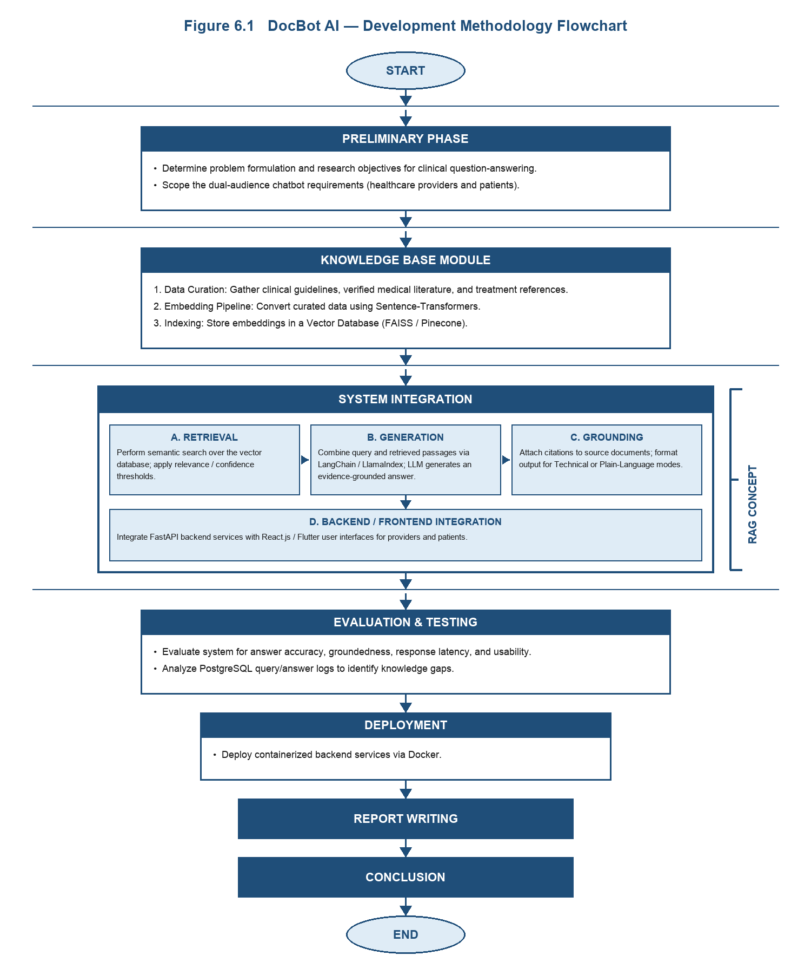
Figure 6.1 Object-Oriented Development Methodology for DocBot AI

7. Tools and Technologies
Tools and Technologies | Version | Rationale / Purpose
Python | 3.10+ | AI and backend development
FastAPI | Latest Stable Version | Backend API development
LangChain / LlamaIndex | Latest Stable Version | RAG pipeline orchestration
LLM API (e.g., GPT-family) or self-hosted open model | Latest Stable Version | Answer generation grounded in retrieved evidence
Sentence-Transformers | Latest Stable Version | Text embedding for semantic retrieval
FAISS / Pinecone | Latest Stable Version | Vector database for semantic search over the medical knowledge base
PostgreSQL | Latest Stable Version | Structured data storage and query/answer logs
React.js / Flutter | Latest Stable Version | Chatbot front-end interface (web/mobile)
Docker | Latest Stable Version | Containerized deployment of backend services
GitHub | Current | Source code management
Visual Studio Code | Current | Code development and editing
Google Colab | Current | GPU-based experimentation and evaluation
Table 7.1 Tools and Technologies for Proposed Project
Main Technologies
- Python: Used for AI model orchestration, retrieval pipeline, and backend services.
- FastAPI: Used to build backend services that connect the chatbot front end with the RAG pipeline.
- LangChain / LlamaIndex: Used to orchestrate retrieval, prompt construction, and citation grounding.
- FAISS / Pinecone: Used to index and semantically search the curated medical knowledge base.
- React.js / Flutter: Used to build the chatbot interface for providers and patients.
- PostgreSQL: Used to store structured data, user sessions, and query/answer logs.
- Docker: Used to containerize and deploy the backend services.

8. Project Stakeholders and Roles
Stakeholder | Role and Responsibilities
The University of Faisalabad | Project sponsor and academic institution
Project Supervisor | Provides guidance, reviews progress, and evaluates project development
Final Year Project Committee | Evaluates the project, presentation, and final results
Student Team | Designs, develops, tests, documents, and presents DocBot AI
Healthcare Providers | Primary users seeking fast, evidence-based answers to support clinical decisions
Patients | Secondary users seeking accessible, trustworthy health information
Medical Content Reviewers / Advisors | Validate the accuracy and currency of the curated medical knowledge base
Table 8.1 Project Stakeholders for Proposed Project

9. Team Members Individual Tasks/Work Division
Student Name | Student Registration Number | Responsibility / Modules
Humna Imran | 2023-BS-AI-017 | Knowledge Base & Retrieval: curating clinical guidelines/literature, building the vector database, embedding pipeline
Ayesha Imran | 2023-BS-AI-057 | LLM Integration & Prompt Engineering: RAG pipeline, citation grounding, hallucination evaluation
Maham Nisar | 2023-BS-AI-058 | Backend & API Development and Frontend & UX: FastAPI services, database, authentication, chatbot interface, testing, documentation, deployment
Table 9.1 Team Member Work Division for Proposed Project
All team members will also work together on final integration, testing, documentation, presentation, and project demonstration.

10. Project Domain
Concept 1: Artificial Intelligence
Artificial intelligence will help the system understand natural-language medical questions and generate accurate, evidence-based answers.
Concept 2: Large Language Models
A large language model will be used to understand user queries and generate fluent, natural-language answers grounded in retrieved evidence.
Concept 3: Retrieval-Augmented Generation (Information Retrieval)
Retrieval-augmented generation will be used to search a curated medical knowledge base and ground the model's answers in verified sources, reducing hallucination.
Concept 4: Web/Mobile Application Development
The project will include a chatbot interface, developed as a web and/or mobile application, providing separate response modes for healthcare providers and patients.
Concept 5: Healthcare Informatics
The project applies AI to a healthcare information context, requiring attention to clinical accuracy, evidence traceability, and responsible handling of health-related queries.

11. Gantt Chart
Task | W1-2 | W2-3 | W3-4 | W4-5 | W5-6 | W6-7 | W7-8 | W8-9
Requirements gathering & knowledge-base scoping
Curating clinical guidelines & literature sources
Knowledge base ingestion & embedding pipeline
Retrieval engine (vector search) development
LLM integration & prompt/RAG design
Citation grounding & confidence thresholding
Backend API development
Chatbot front-end development
System integration
Testing (accuracy, groundedness, latency, usability)
Documentation & final presentation
Figure 11.1 Gantt Chart
Major Dependencies
- Knowledge-base curation must be completed before the embedding/ingestion pipeline can run.
- The retrieval engine must be functional before RAG and citation grounding can be integrated.
- The RAG pipeline is required before the chatbot can generate grounded answers.
- Backend and front-end integration must be complete before end-to-end testing begins.
- Final testing depends on completion of all major modules.

12. Conclusion
DocBot AI is an AI-based clinical question-answering system built to give healthcare providers and patients fast, accurate, evidence-grounded answers to medical queries. It combines a large language model with retrieval-augmented generation over a curated medical knowledge base, which should substantially reduce the hallucination risk that limits the safe use of general-purpose LLMs in healthcare. Every answer also comes with citations, so it can be checked independently. The project focuses especially on supporting faster, more informed decision-making in resource-constrained settings where specialist access is limited. Building the proposed system will also give the team practical experience in large language models, retrieval-augmented generation, backend and API development, and applied healthcare informatics. Overall, DocBot AI aims to provide a reliable, transparent information layer that complements professional medical care rather than replacing it.

References
[1] Lewis, P., Perez, E., Piktus, A., Petroni, F., Karpukhin, V., Goyal, N., Küttler, H., Lewis, M., Yih, W., Rocktäschel, T., Riedel, S., & Kiela, D. (2020). Retrieval-augmented generation for knowledge-intensive NLP tasks. Advances in Neural Information Processing Systems, 33, 9459–9474. https://arxiv.org/abs/2005.11401
[2] Gao, Y., Xiong, Y., Gao, X., Jia, K., Pan, J., Bi, Y., Dai, Y., Sun, J., & Wang, H. (2024). Retrieval-augmented generation for large language models: A survey. arXiv preprint arXiv:2312.10997. https://arxiv.org/abs/2312.10997
[3] Singhal, K., Azizi, S., Tu, T., Mahdavi, S. S., Wei, J., Chung, H. W., et al. (2023). Large language models encode clinical knowledge. Nature, 620, 172–180. https://doi.org/10.1038/s41586-023-06291-2
[4] Singhal, K., Tu, T., Gottweis, J., Sayres, R., Wulczyn, E., Hou, L., et al. (2025). Toward expert-level medical question answering with large language models. Nature Medicine, 31(3), 943–950. https://doi.org/10.1038/s41591-024-03423-7
[5] Zakka, C., Shad, R., Chaurasia, A., Dalal, A. R., Kim, J. L., Moor, M., et al. (2024). Almanac: Retrieval-augmented language models for clinical medicine. NEJM AI, 1(2). https://doi.org/10.1056/AIoa2300068
[6] Pham, D. K., & Vo, B. Q. (2024). Towards reliable medical question answering: Techniques and challenges in mitigating hallucinations in language models. arXiv preprint arXiv:2408.13808. https://arxiv.org/abs/2408.13808
[7] Xu, S., Yan, Z., Dai, C., & Wu, F. (2025). MEGA-RAG: A retrieval-augmented generation framework with multi-evidence guided answer refinement for mitigating hallucinations of LLMs in public health. Frontiers in Public Health, 13, 1635381. https://doi.org/10.3389/fpubh.2025.1635381
[8] Wang, C., & Chen, Y. (2026). Evaluating large language models for evidence-based clinical question answering. Patterns, 7(5), 101519. https://doi.org/10.1016/j.patter.2026.101519
[9] Low, Y. S., Jackson, M. L., Hyde, R. J., Brown, R. E., et al. (2025). Answering real-world clinical questions using large language model, retrieval-augmented generation, and agentic systems. Digital Health, 11. https://doi.org/10.1177/20552076251348850
[10] Basu, S., & Huynh, B. (2026). Mitigating hallucinations in healthcare AI: A systematic review of evidence-based strategies. BMC Health Services Research, 26, 1115. https://doi.org/10.1186/s12913-026-14851-1

